Week 10

Lab program 7:

7. Write a program to demonstrate generics with multiple object parameters.

class Gen<T1, T2>

{

T1 ob1;

T2 ob2;

Gen(T1 o1, T2 o2)

{

ob1 = o1;

ob2 = o2;

}

void showTypes()

{

System.out.println("Type of T1 is " +ob1.getClass().getName());

System.out.println("Type of T2 is " +ob2.getClass().getName());

}

T1 getob1() {

return ob1;

}

T2 getob2() {

return ob2;

}

}

class demo

{

public static void main(String args[])

{

Gen<Integer, String> obj = new Gen<Integer, String>(100, "hello!");

obj.showTypes();

int v = obj.getob1();

System.out.println("T1 value: " + v);

String str = obj.getob2();

System.out.println("T2 value: " + str);

}

}

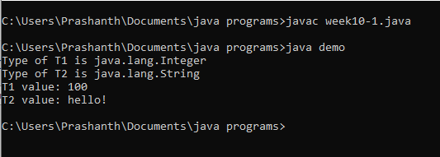

8. Write a program that demonstrates handling of exceptions in inheritance tree. Create a base class

called “Father” and derived class called “Son” which extends the base class. In Father class,

implement a constructor which takes the age and throws the exception Wrong Age( ) when the input

age=father’s age.

import java.util.Scanner;

class WrongAge extends Exception{

int age;

WrongAge(int x)

{

age=x;

}

public String toString()

{

return "AGE OF SON="+age+" IS ENTERED INCORRECTLY";

}

}

class father

{

int a;

father(int x)

{

a=x;

}

}

class son extends father{

int age;

son(int fage,int sage){

super(fage);

age=sage;

}

void compute() throws WrongAge{

if(age>=a)

{

throw new WrongAge(age);

}

else{

System.out.println("THE AGES ARE ENTERED CORECTLY");

System.out.println("FATHER'S AGE="+a+"\t"+"SON'S AGE="+age);

}

}

}

class expmain

{

public static void main(String args[])

{

Scanner s=new Scanner(System.in);

System.out.println("ENTER FATHER'S AGE");

int f=s.nextInt();

System.out.println("ENTER SON'S AGE");

int so=s.nextInt();

son ss=new son(f,so);

try{

ss.compute();

}catch(WrongAge e)

{

System.out.println(e);

}

}

}

